**Dr AQ KHAN INSTITUTE OF SPACE AND TECHNOLOGY**



# SUBMITTED BY: VISHA HAMEED

# 232201044

# IV-A

# PROJECT ERD

# COURSE : ADMS LAB

# SUBMITED TO: SIR UMAR NASEER

ERD:

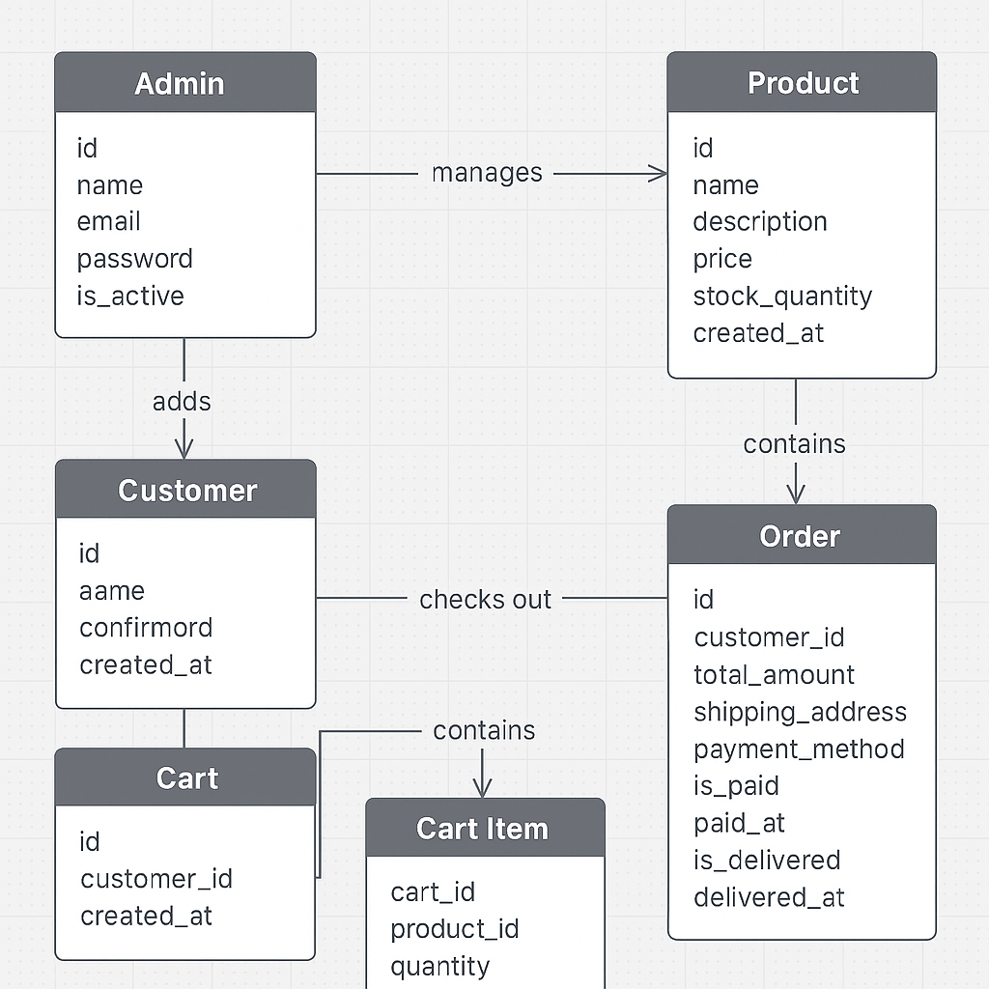

FRONTEND AND WORKING:

LOGIN PAGE:First one is the login page from where customer as well as admin can login to the website

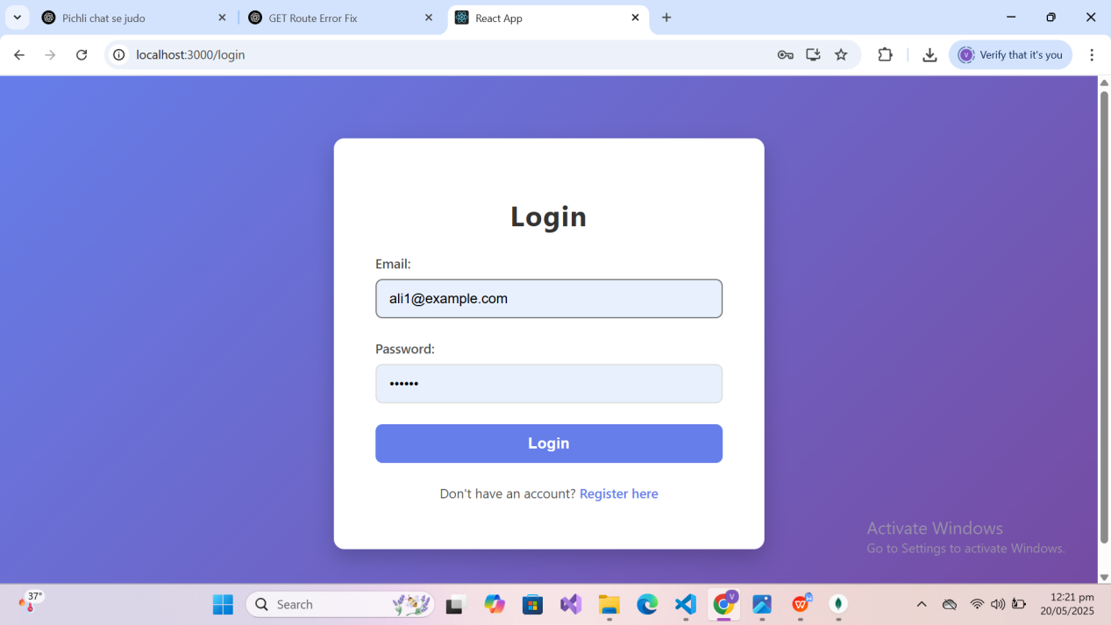

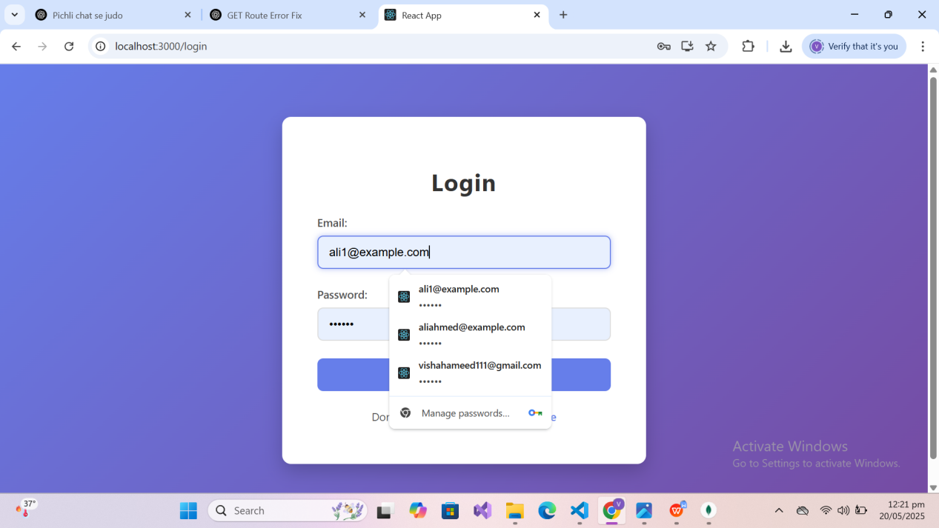

* If customer has not logged in before then he has to first register himself then login

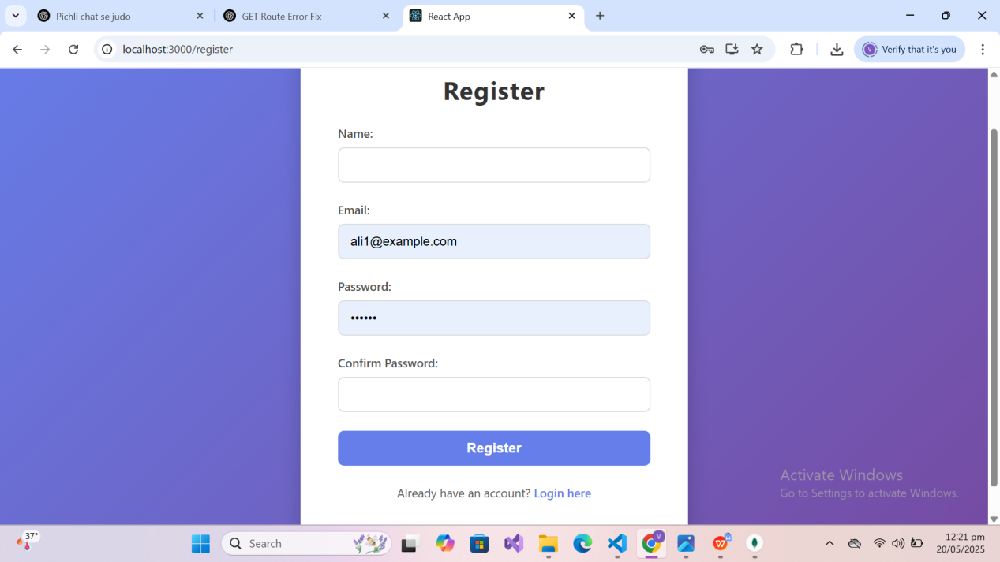

CUSTOMER SERVICES:

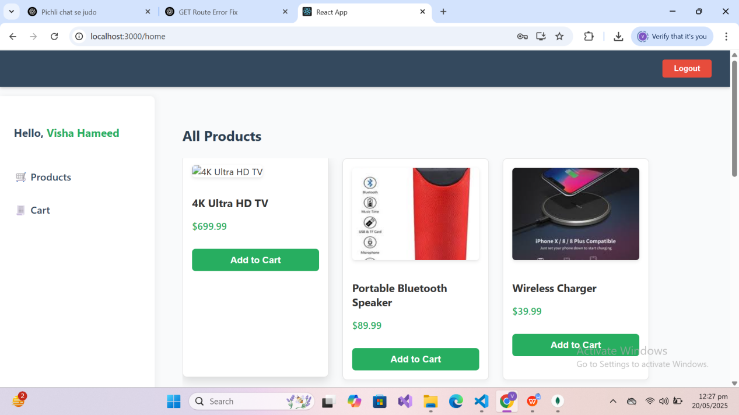

* Once the customer has logged in to the website he can see all the listed products along with their images and details

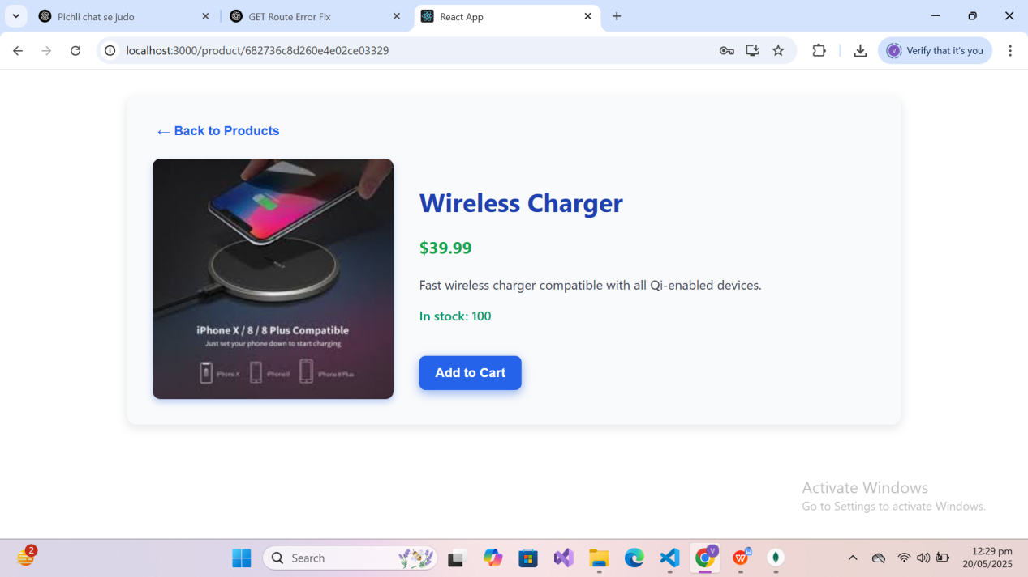

* Showing details of a product

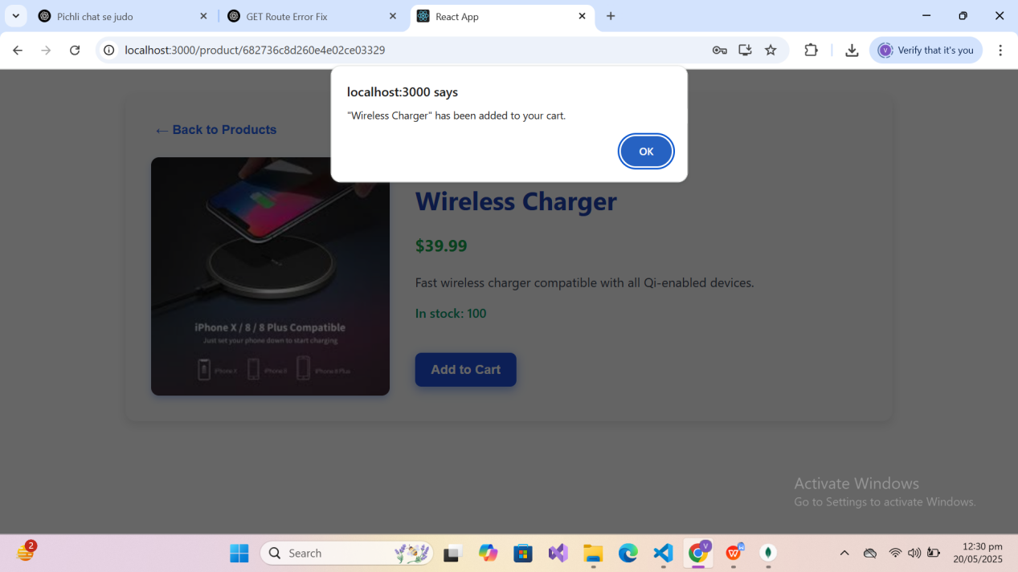

* Adding to the customers cart

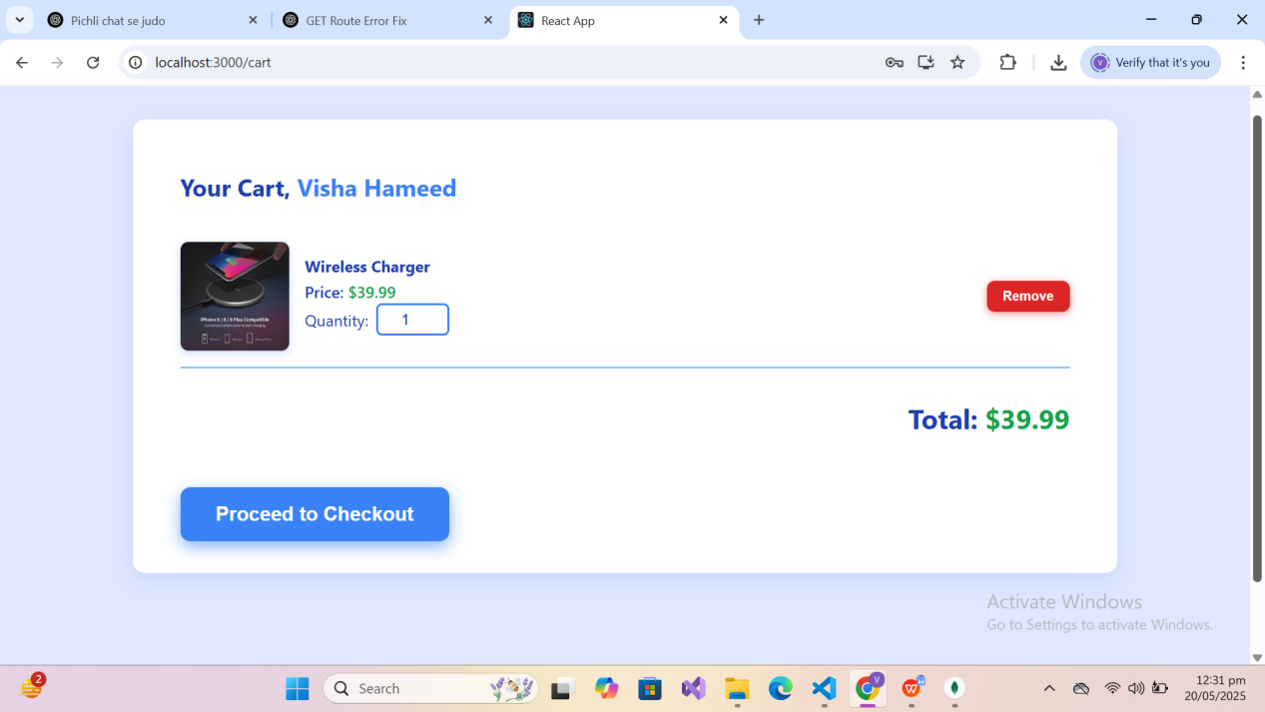

* User can view his cart and proceed to checkout or remove it

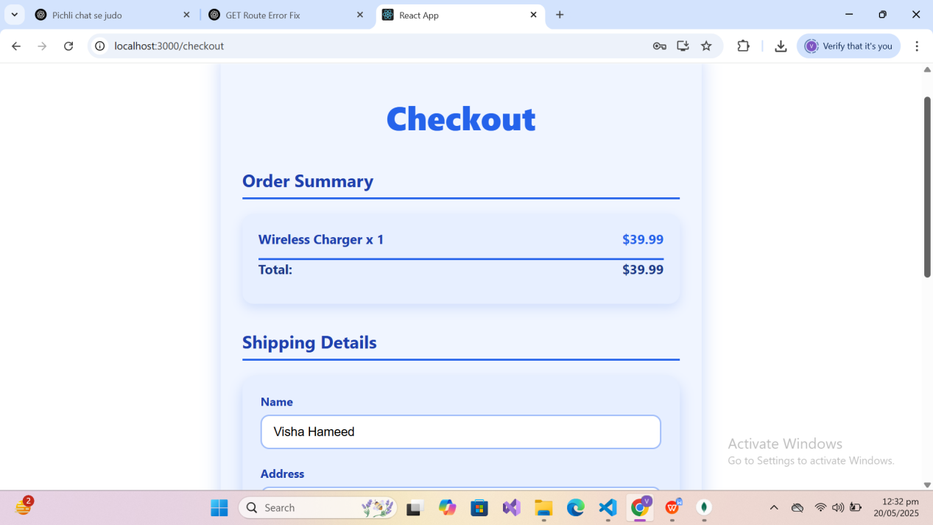

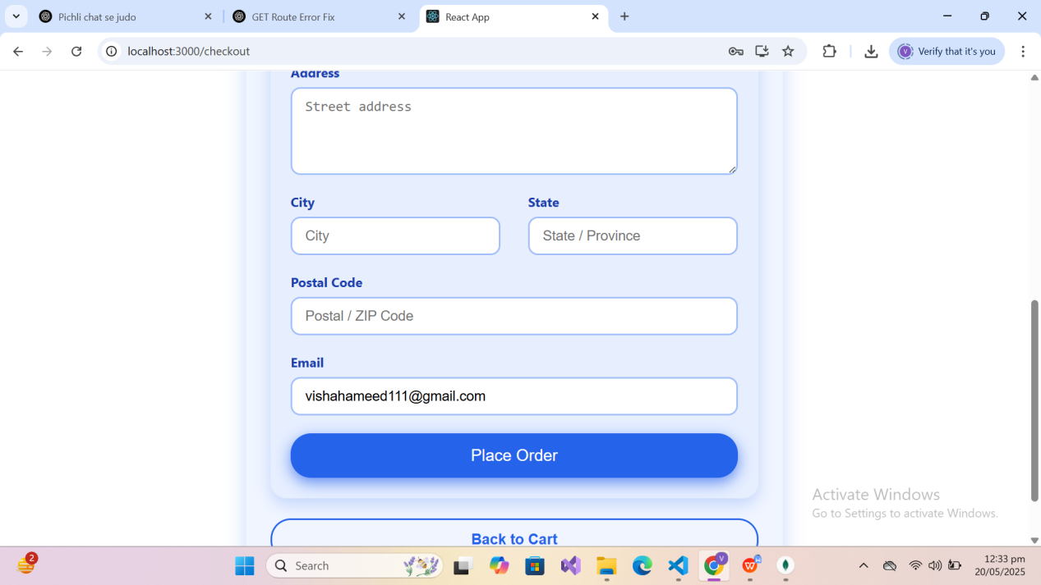

* Once order is placed

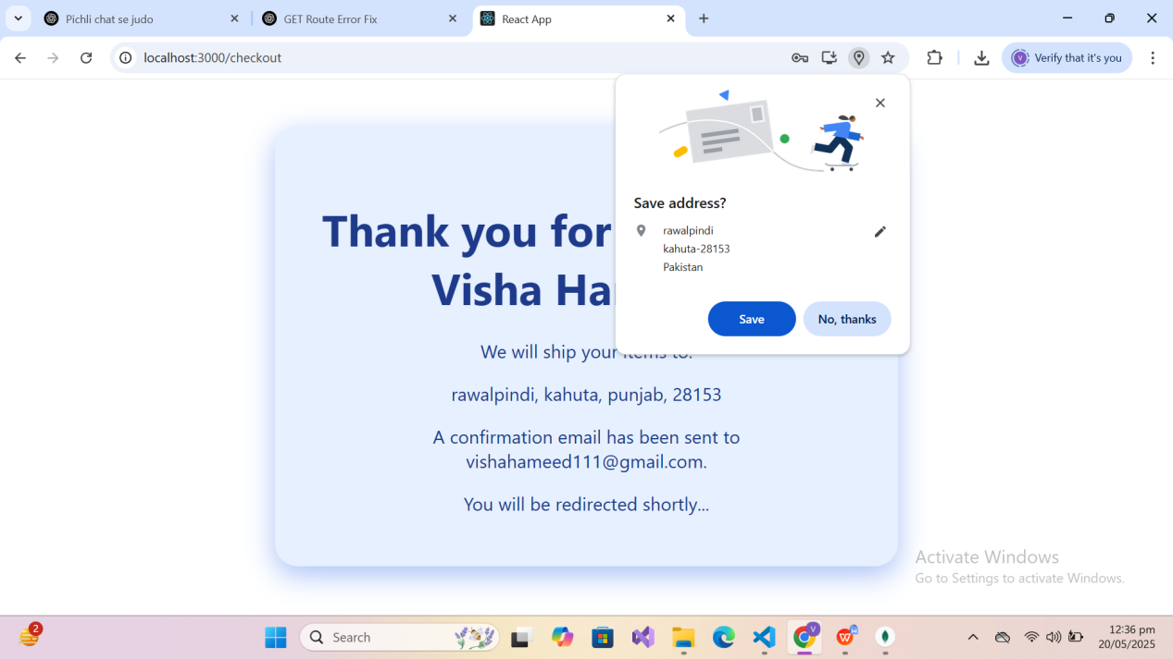

ADMIN SERVICES:

* ADMIN DASHBOARD:

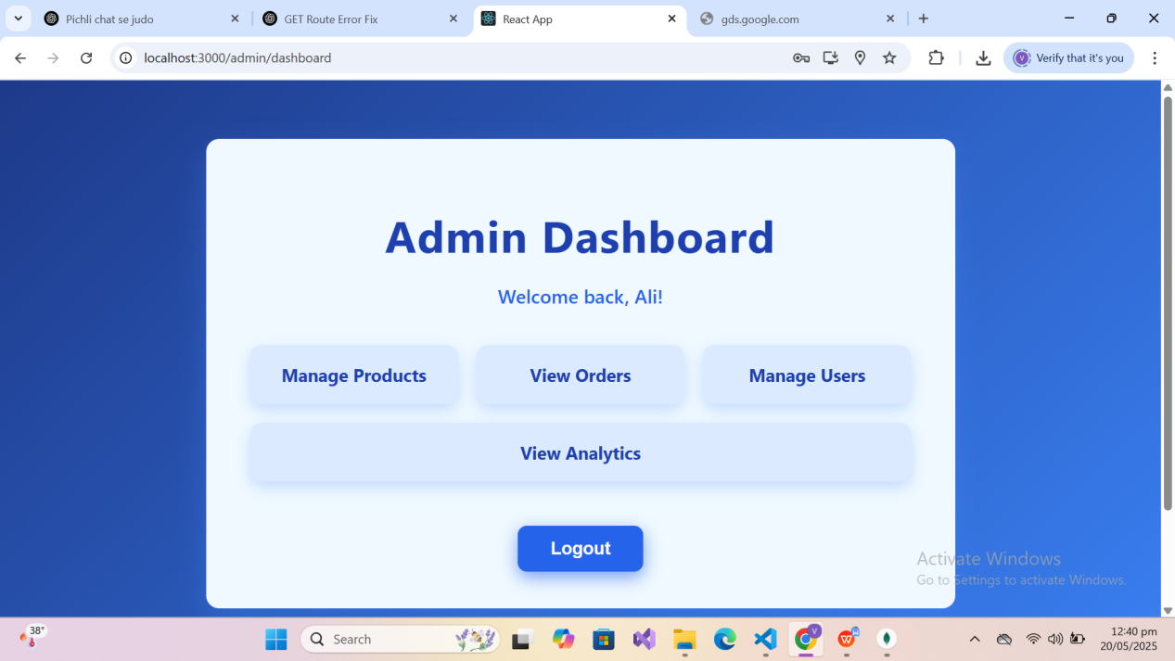

MANAGE PRODUCTS:

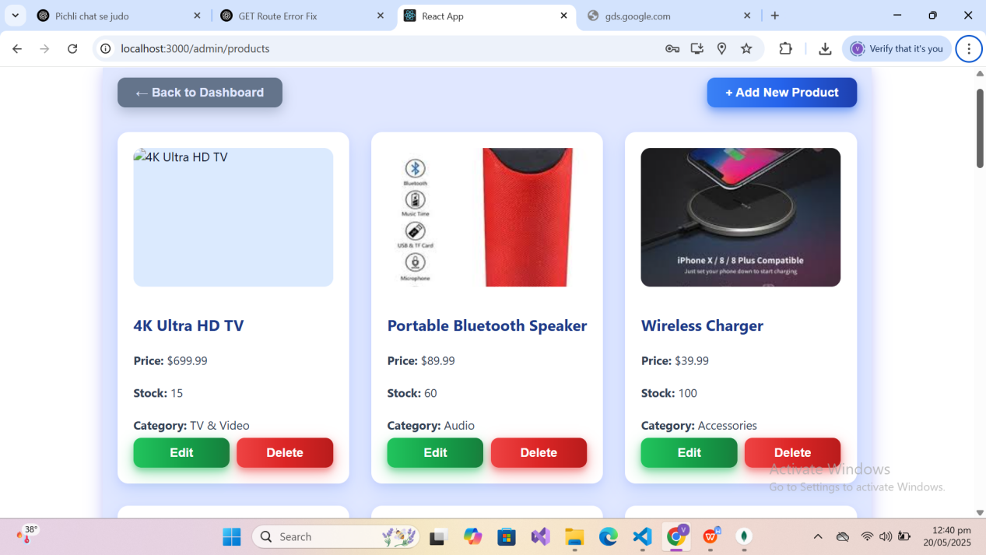

EDIT PRODUCTS:

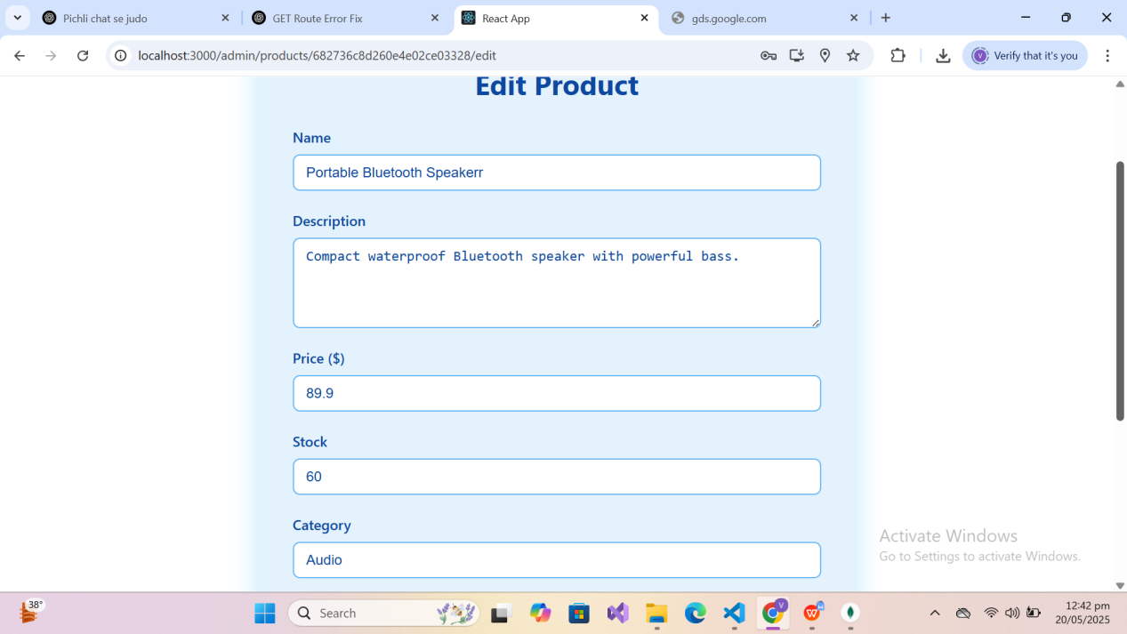

VIEW ORDERS:

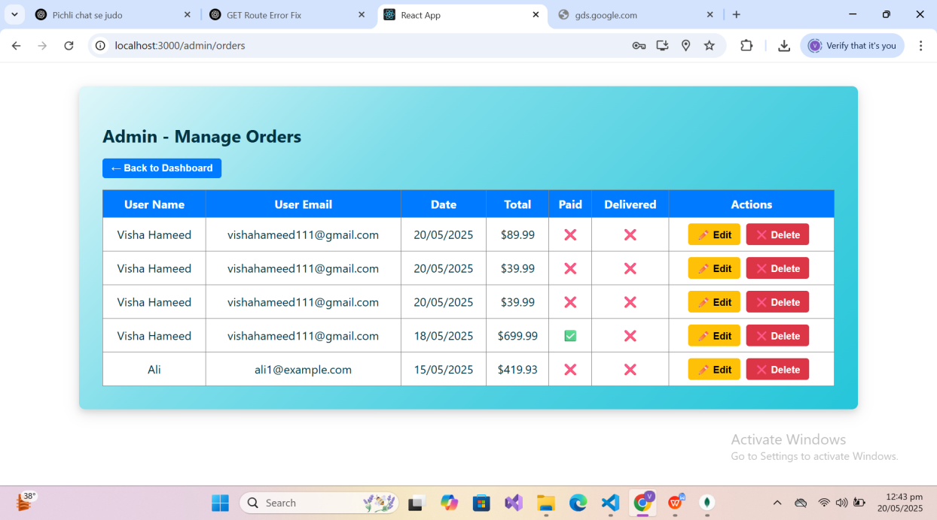

MANAGE USERS :

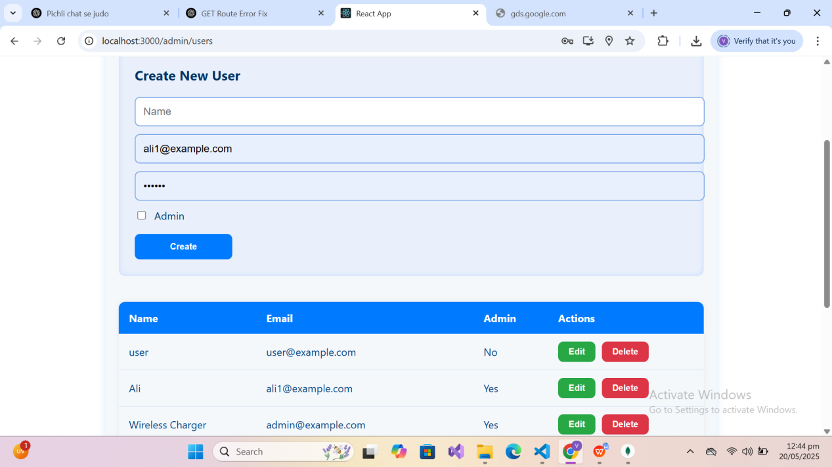

SHOW ADMIN ANALYTICS (STILL IN PROGRESS):

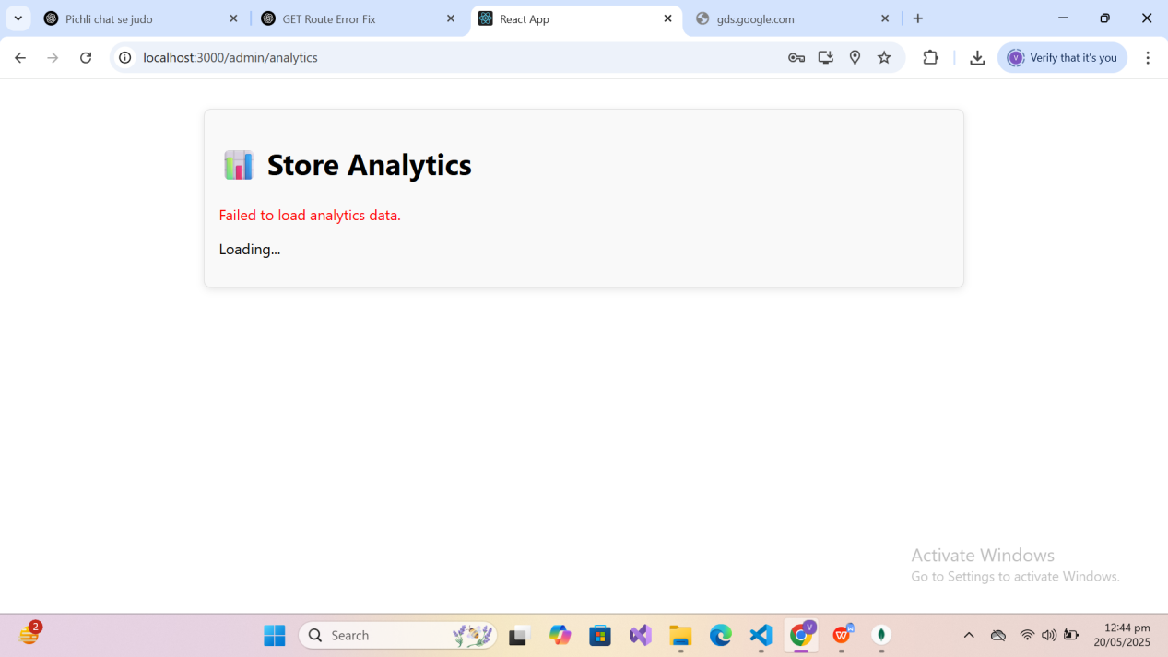

MONGODB:

